Project Planning Phase
Project Planning Template (Product Backlog, Sprint Planning, Stories, Story Points)
Date | 15 February 2025
Team ID
Project Name | Team Enrollment Confirmation - Import Data using Transform Maps (Spreadsheet)
Team Size | 4
Team Leader | SRIKAVI T
Team Members | ISWARYA S, YOGASRI S, KEERTHIKA L
Maximum Marks | 5 Marks

1. Product Backlog, Sprint Schedule, and Estimation (4 Marks)
The product backlog below breaks the Team Enrollment Confirmation project into four sprints of 20 story points each (80 story points in total). The project uses a spreadsheet as the data source and Transform Maps to import the data into the Team Enrollment table.
Sprint | Functional Requirement (Epic) | User Story Number | User Story / Task | Story Points | Priority | Team Members
Sprint-1 | Data Source Setup | USN-1 | As a team leader, I can prepare the enrollment spreadsheet (Excel) with team member name, email, role and enrollment status columns. | 3 | High | Srikavi T
Sprint-1 | Data Source Setup | USN-2 | As an admin, I can create the Team Enrollment custom table with all required fields to store the imported data. | 5 | High | Iswarya S
Sprint-1 | Data Source Setup | USN-3 | As an admin, I can configure user roles and access controls (ACL) for the Team Enrollment table. | 3 | Medium | Yogasri S
Sprint-1 | Data Source Setup | USN-4 | As an admin, I can load the spreadsheet as a data source and create the Import Set table. | 5 | High | Keerthika L
Sprint-1 | Data Source Setup | USN-5 | As a team member, I can validate the file format, column headers and sample data before import. | 4 | High | Srikavi T
Sprint-2 | Transform Map Configuration | USN-6 | As an admin, I can create a Transform Map from the Import Set table to the Team Enrollment table. | 5 | High | Iswarya S
Sprint-2 | Transform Map Configuration | USN-7 | As an admin, I can map source fields to target fields so each spreadsheet column lands in the correct field. | 4 | High | Yogasri S
Sprint-2 | Transform Map Configuration | USN-8 | As an admin, I can coalesce on the email field so duplicate enrollment records are not created. | 3 | High | Keerthika L
Sprint-2 | Transform Map Configuration | USN-9 | As an admin, I can add a transform script to clean data (trim spaces, standardize case) during import. | 4 | Medium | Srikavi T
Sprint-2 | Transform Map Configuration | USN-10 | As an admin, I can run the transform and verify that records are imported into the target table. | 4 | High | Iswarya S
Sprint-3 | Enrollment Confirmation | USN-11 | As an admin, I can add an Enrollment Status field with choices Pending, Confirmed and Rejected. | 3 | High | Yogasri S
Sprint-3 | Enrollment Confirmation | USN-12 | As an admin, I can create a business rule that sets status to Confirmed when all required details are present. | 5 | High | Keerthika L
Sprint-3 | Enrollment Confirmation | USN-13 | As a team member, I will receive a confirmation email once my enrollment is confirmed. | 5 | High | Srikavi T
Sprint-3 | Enrollment Confirmation | USN-14 | As a team leader, I can view a list and report of confirmed enrollments. | 4 | Medium | Iswarya S
Sprint-3 | Enrollment Confirmation | USN-15 | As an admin, I can review import logs and skipped or ignored rows to correct errors. | 3 | Medium | Yogasri S
Sprint-4 | Testing & Deployment | USN-16 | As a tester, I can import a valid dataset and confirm all records are transformed correctly. | 4 | High | Keerthika L
Sprint-4 | Testing & Deployment | USN-17 | As a tester, I can import invalid and duplicate data and confirm it is handled properly. | 4 | High | Yogasri S
Sprint-4 | Testing & Deployment | USN-18 | As a team, we can perform user acceptance testing and fix reported defects. | 5 | High | Iswarya S
Sprint-4 | Testing & Deployment | USN-19 | As a team leader, I can prepare the project documentation and final demo. | 4 | Medium | Srikavi T
Sprint-4 | Testing & Deployment | USN-20 | As an admin, I can move the completed configuration to the final instance using an update set. | 3 | Medium | Keerthika L

2. Project Tracker, Velocity & Burndown Chart (4 Marks)
Sprint | Total Story Points | Duration | Sprint Start Date | Sprint End Date (Planned) | Story Points Completed (as on Planned End Date) | Sprint Release Date (Actual)
Sprint-1 | 20 | 6 Days | 24 Oct 2022 | 29 Oct 2022 | 20 | 29 Oct 2022
Sprint-2 | 20 | 6 Days | 31 Oct 2022 | 05 Nov 2022
Sprint-3 | 20 | 6 Days | 07 Nov 2022 | 12 Nov 2022
Sprint-4 | 20 | 6 Days | 14 Nov 2022 | 19 Nov 2022

Velocity
Each sprint has a duration of 6 days and a total of 20 story points, so the team's velocity is 20 story points per sprint.
Average velocity (AV) per day = Velocity / Sprint duration = 20 / 6 = 3.33 story points per day
Across the whole project: 80 story points over 4 sprints (24 days) gives the same 3.33 story points per day. For the 10-day example in the template (20 points per sprint), AV = 20 / 10 = 2 story points per day.

Burndown Chart
A burndown chart is a graphical representation of work left to do versus time. It is often used in agile software development methodologies such as Scrum, but it can be applied to any project with measurable progress over time.
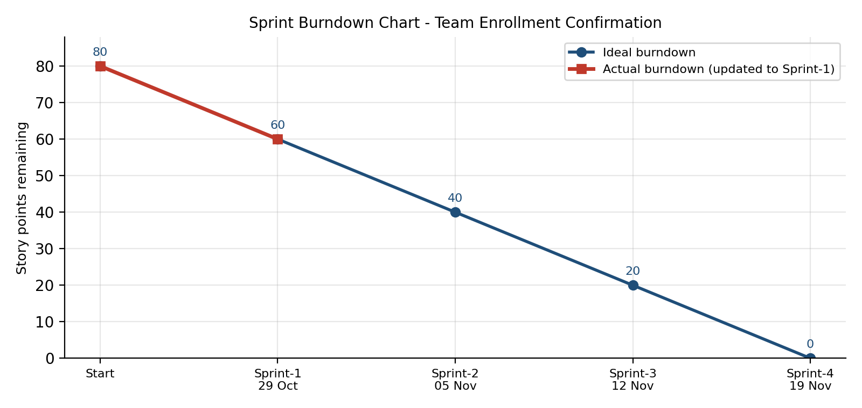
Sprint End | Planned Points Burned | Ideal Points Remaining | Actual Points Remaining
Start | - | 80 | 80
Sprint-1 (29 Oct 2022) | 20 | 60 | 60
Sprint-2 (05 Nov 2022) | 20 | 40
Sprint-3 (12 Nov 2022) | 20 | 20
Sprint-4 (19 Nov 2022) | 20 | 0
Actual values for Sprint-2 to Sprint-4 are to be filled in as each sprint completes.

Reference
https://www.atlassian.com/agile/project-management
https://www.atlassian.com/agile/tutorials/how-to-do-scrum-with-jira-software
https://www.atlassian.com/agile/tutorials/epics
https://www.atlassian.com/agile/tutorials/sprints
https://www.atlassian.com/agile/project-management/estimation
https://www.atlassian.com/agile/tutorials/burndown-charts
https://www.visual-paradigm.com/scrum/scrum-burndown-chart/

